RIPHAH INTERNATIONAL UNIVERSITY


Faculty of Computing
Object Oriented Programming Lab
Lab 5
Operators, Control Structures & the toString() Method
Submitted By: Khadija Binte Asif
SAP ID: 77954
Submitted To: Miss Nayab Khalid

Lab Manual Development Team

Supervision and Coordination

Hira Jaffar
Lecturer
Faculty of Computing

Lab Designers
Nayab Khalid Kayani
Teaching Fellow
Faculty of Computing

Lab Tasks:
Lab Task 1: Movie Ticket Counter (Unary Operators)
Create a class CinemaHall that tracks how many seats have been booked out of a fixed capacity, using increment/decrement to book and cancel seats.
Requirements:
- Create a class CinemaHall with a private int bookedSeats (start at 0) and a final int capacity (e.g. 100).
- Write a method bookSeat() that increments bookedSeats using the ++ operator, but only if seats remain.
- Write a method cancelBooking() that decrements bookedSeats using the -- operator, but never below 0.
- Write a method showStatus() that prints the number of booked seats and the number of seats remaining.
- In main(), book 5 seats, cancel 2, then display the status.
Hint: Use an if check before ++ / -- so the counter cannot go below 0 or above capacity.

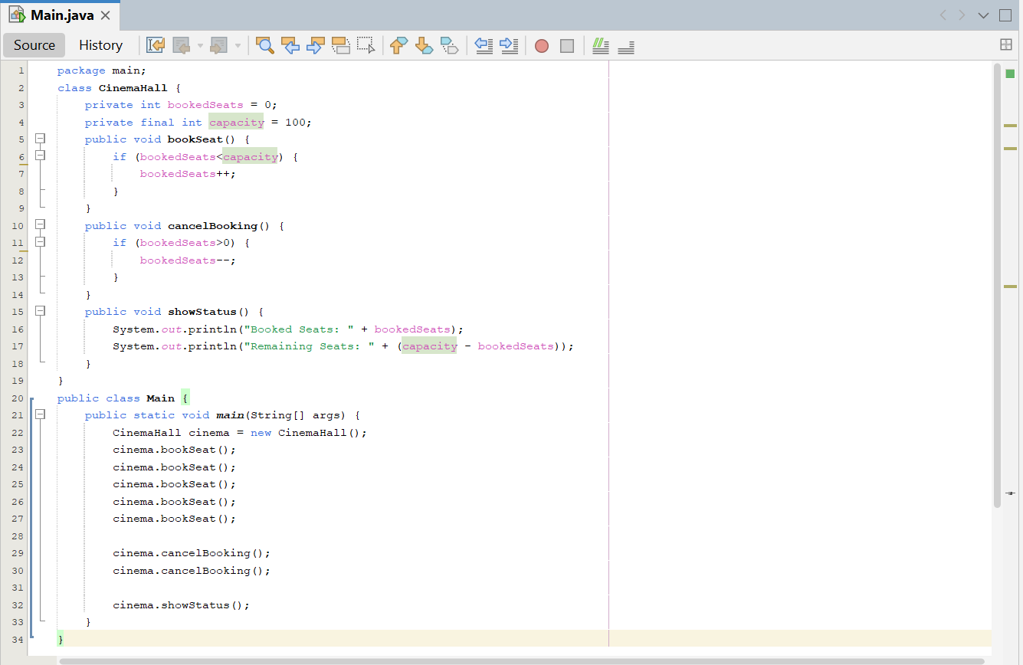
Solution:

Output:
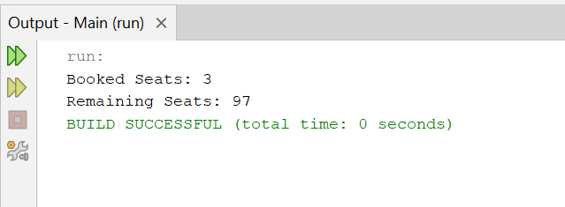

Lab Task 2: Utility Bill Category (if / else-if Ladder)
Create a class UtilityBill that classifies a household's electricity usage into a billing slab using an else-if ladder.
Requirements:
- Create a class UtilityBill with attributes consumerName (String) and unitsConsumed (int).
- Write a method classifySlab() with an if / else-if / else ladder that prints: "Lifeline" for units below 100, "Slab-1" for 100–200, "Slab-2" for 201–300, "Slab-3" for 301–700, and "Slab-4" above 700.
- Compute and print an approximate bill amount based on a fixed rate per unit for each slab (choose your own reasonable rates).
- Create at least four UtilityBill objects covering different slabs and display each one's classification and bill.
Hint: Order your conditions from the highest threshold to the lowest, exactly like the grading example in Section 3.

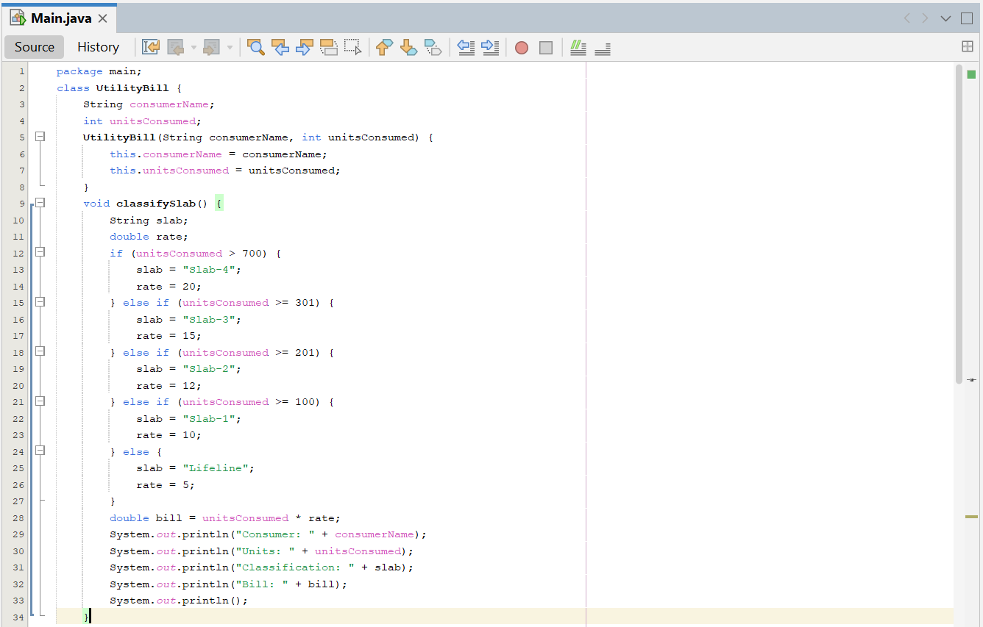
Solution:

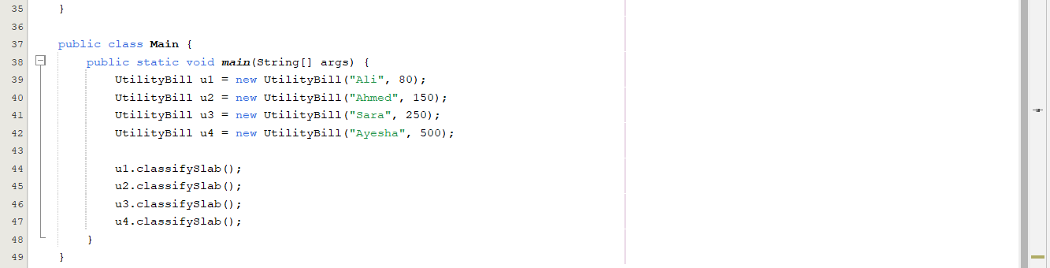

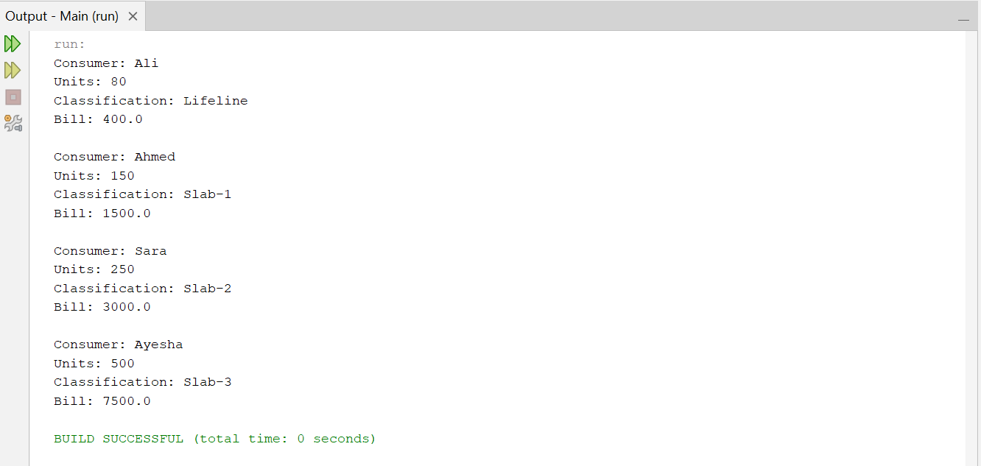
Output:

Lab Task 3: Bank Account Summary (Overriding toString())
Create a class BankAccount whose objects print a clean, formatted summary automatically when passed to println().
Requirements:
- Create a class BankAccount with private attributes accountHolder (String), accountNumber (String) and balance (double).
- Implement a constructor that initializes all three attributes.
- Override toString() to return a formatted string such as: "Account[1234-5678] — John Doe — Balance: $15000.00".
- In main(), create two BankAccount objects with sample data.
- Print both objects directly with System.out.println() and confirm your overridden toString() runs automatically.
Hint: Use String.format("%.2f", balance) inside toString() to keep two decimal places on the balance.

Solution:
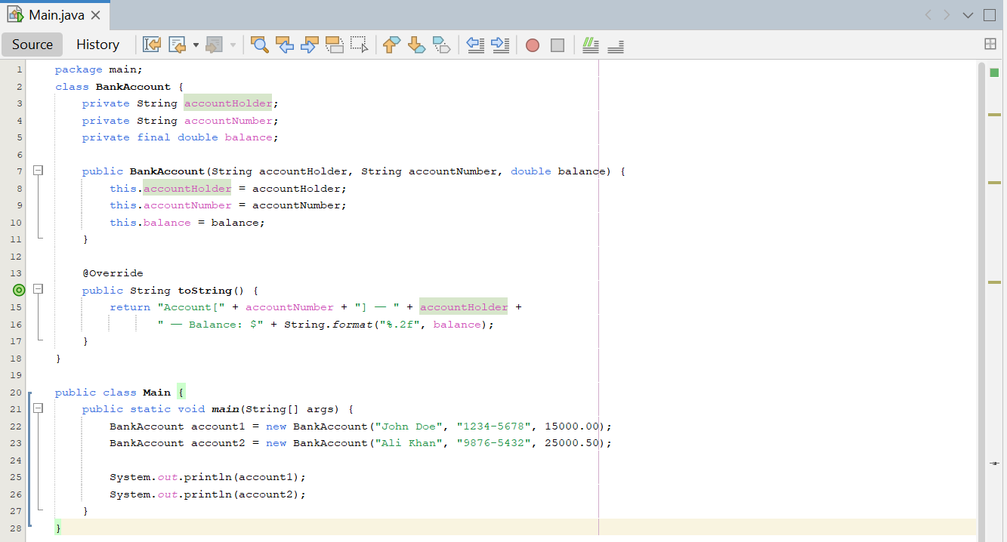

Output:


